|  |  |
| --- | --- |
| **Subject Code:** | CSIT321 |
| **Subject Name:** | Capstone Project |
| **Submission Type:** | Online/Turnitin |
| **Project Title:** | Design Document |
| **Student/Team Name:** | The Hexacore - Avni Pramod, Mohammad Mawiz Ansari,  Syed Sheharyar Ahmed, Mohammed Shehin Kalady,  Nihal Muhamed, Sivajith Ajith Kumar |
| **Student Number:** | 8047984, 8335084, 8337354, 8526035, 8276985, 8404744 |
| **Student Phone/Mobile No.** | +971 54 286 1007, +971 58 597 5201, +971 54 396 0049,  +971 56 636 9656, +971 56 379 6066, +971 55 963 3088 |
| **Student E-mail:** | [ap564@uowmail.edu.au](mailto:ap564@uowmail.edu.au), [mma365@uowmail.edu.au](mailto:mma365@uowmail.edu.au), [ssa530@uowmail.edu.au](mailto:ssa530@uowmail.edu.au), [msk965@uowmail.edu.au](mailto:msk965@uowmail.edu.au), [nm438@uowmail.edu.au](mailto:nm438@uowmail.edu.au), sak481@uowmail.edu.au |
| **Lecturer Name:** | Prof. Farhad Oroumchian |
| **Due Date:** | 28/11/2025 |
| **Date Submitted:** | 28/11/2025 |

  
  
**Proposal Cover Sheet**

|  |  |
| --- | --- |
| **PLAGIARISM:** The penalty for deliberate plagiarism is FAILURE in the subject. Plagiarism is cheating by using the written ideas or submitted work of someone else. UOWD has a strong policy against plagiarism.  The University of Wollongong in Dubai also endorses a policy of non-discriminatory language practice and presentation.  **PLEASE NOTE:**STUDENTS MUST RETAIN A COPY OF ANY WORK SUBMITTED | **DECLARATION:** I/We certify that this is entirely my/our own work, except where I/we have given fully-documented references to the work of others, and that the material contained in this document has not previously been submitted for assessment in any formal course of study. I/we understand the definition and consequences of plagiarism. We/I declare that the project proposal has not been used in any UOWD courses before and that this project idea is a total new idea of the project team  **Signature of Student: Avni Mawiz Sheharyar Shehin Nihal Sivajith** |
| |  | | --- | | **Optional Marks:** | | **Comments:** | | | | |

https://my.uowdubai.ac.ae/images/scissors.gif

|  |  |  |  |  |  |  |  |  |  |  |
| --- | --- | --- | --- | --- | --- | --- | --- | --- | --- | --- |
| |  |  | | --- | --- | | **Lecturer Project Proposal Receipt**(To be filled in by student and retained by Lecturer upon return of assignment) | | | **Subject:** CSIT321 - Project | **Project Title:** S.H.I.E.L.D | | **Student / Team Name:** The HexaCore | **Student Number:** 8047984, 8335084, 8337354, 8526035, 8276985, 8404744 | | **Due Date:** 28/11/2025 | **Date Submitted:** 28/11/2025 | | **Signature of Student: Avni Mawiz Sheharyar Shehin Nihal Sivajith** | | |

https://my.uowdubai.ac.ae/images/scissors.gif

|  |  |  |  |  |  |  |  |  |  |  |
| --- | --- | --- | --- | --- | --- | --- | --- | --- | --- | --- |
| |  |  | | --- | --- | | **Student Project Proposal Receipt** (To be filled in and retained by Student upon submission of assignment) | | | **Subject:** CSIT321 - Project | **Project Title:** S.H.I.E.L.D | | **Student/Team Name:** The HexaCore | **Student Number:** 8047984, 8335084, 8337354, 8526035, 8276985, 8404744 | | **Due Date:** 28/11/2025 | **Date Submitted:** 28/11/2025 | | **Signature of Lecturer:** | | |
|  |

Design Document

CSIT321 Autumn 2025 Team The Hexacore

8404744 Sivajith Ajith Kumar

8335084 Mohammad Mawiz Ansari  
8047984 Avni Pramod

8337354 Syed Sheharyar Ahmed

8526035 Mohammed Shehin Kalady  
8276985 Nihal Muhamed

Table of Contents

Introduction 3

Purpose 3

Project Scope 3

Out of Scope Components 3

System Overview 5

Activity Diagram 5

Patient Health Monitoring System 5

Doctor Clinical Portal system 7

Use Case Diagram 9

Sequence Diagram 10

Diagram 1: Normal Operation 10

Diagram 2: Critical Alert & Clinician Dashboard Sync 11

System Architecture 12

Architectural Design 12

Decomposition Description 12

Design Rationale 13

High Level System Architecture Diagram 14

Human Interface Design 15

Mobile Application UI 15

Web Portal UI 22

Additional details for clarity of project 23

Ethical Considerations 23

Privacy & Security 23

Conclusion 24

Work Distribution 25

# Introduction

## Purpose

This document outlines the software design for the S.H.I.E.L.D heart health monitoring system. It focuses on the architectural structure and system interaction modelling. It defines the system’s major subsystems, their relationships, and the behavioural flows represented through use case, activity, and sequence diagrams. The intended audience is the design team, project stakeholders, and reviewers who need a clear, abstract view of how the system operates without diving into low-level implementation details.

## Project Scope

* **Development of a Privacy-First Cardiovascular Monitoring System:** The project focuses on designing and implementing an AI-powered, on-device cardiovascular risk monitoring platform that prioritizes user privacy through Federated Learning and Edge AI.
* **IoT Data Integration and Processing:** The system will collect vital-sign data from consumer wearables (e.g., Apple Watch) and medical-grade devices, process these readings locally, and generate personalized risk scores.
* **Clinician Collaboration via Secure Dashboard:** A secure, hospital-verified clinician portal will be developed to allow registered doctors, nurses, and cardiologists to monitor patient alerts, insights, and real-time risk levels.
* **Explainable AI (XAI) for Transparency:** The platform will provide patients and clinicians with clear, human-readable “Reason Codes” explaining the factors influencing each risk score.
* **Prototype Validation and Usability Testing:** The project includes prototyping on Arduino IDE or PlatformIO (ESP32-compatible) for AI validation, developing the mobile app and backend, and conducting controlled user testing to demonstrate system feasibility.

## Out of Scope Components

* **Medical Diagnosis:** S.H.I.E.L.D. will not function as a diagnostic tool, provide medical decisions, or replace certified clinical judgement, though future versions may incorporate deeper clinical analytics.
* **Nationwide EMR/Hospital System Integration:** Full integration with Electronic Medical Records (EMR), national health databases, or hospital infrastructure is excluded due to regulatory and technical constraints but remains a future goal.
* **Insurance, Billing, or Healthcare Financial Systems:** Features that connect with insurance providers, automate billing, or generate legally compliant medical reports are beyond current capabilities but could be explored in post-academic development.
* **Large-Scale Clinical Trials:** Real-world deployment involving thousands of patients, regulatory approvals, and long-term clinical studies cannot be implemented at this stage, though the system architecture is built for future scalability.
* **Advanced Machine Learning Infrastructure:** Cloud-based distributed training clusters, continuous-learning pipelines, or real-world dataset ingestion at a national scale are not achievable within the scope of a university project but remain part of the long-term vision.

# System Overview

## Activity Diagram

### Patient Health Monitoring System

#### End User: Patient

#### Diagram Overview

The patient diagram illustrates a user-driven health data collection system where the patient interacts with a mobile application to monitor their health through multiple input methods.

#### Data Flow Analysis

##### Authentication Data Flow:

User Input → System Validation → Access Grant/Denial

**Data types :** Username , Password

**Flow Direction :**Patient → System (one way for security)

**Validations :** Credentials checked against the stored records.

**Output :** Session token , Dashboard Access

##### Manual Entry Data Flow:

Patient Input → Validation → Storage → AI Processing

**Data types :** Blood pressuring readings, Symptom description, General health observation.

**Flow Characteristics:**

* **Structured Input:** Systematic, predefined format for data entry.
* **Real-time Validation:** Real-time feedback during data entry that verifies accuracy, plausibility, and format compliance as the user types.
* **Immediate Storage:** instantaneous, persistent  saving of user-generated health data directly into a secure database when it passes validation without any intermediate caching or delayed processing.
* **Batch Processing:**Scheduled, bulk processing of accumulated rather than real-time analysis of individual data points.

##### Wearable Data Flow:

Wearable Device → Bluetooth/Wi-Fi → System → Storage → AI Processing

* Wearable Data Flow refers to continuous, real-time streaming of biometric data from wearable devices through secure wireless transmission to healthcare systems, enabling persistent monitoring and immediate analysis without user intervention.

### Doctor Clinical Portal system

#### End User: Doctor

#### Diagram Overview

Authorized medical professionals can access patient data, evaluate AI-generated insights,        and offer clinical recommendations using the Doctor Clinical Portal System, a secure   healthcare platform.

#### Data Flow Analysis

##### Authentication Phase:

* Verify medical professional identity and authorization.

Display Login → Enter Doctor Credentials → Authenticate Doctor → [Invalid/Valid]

Process Details:

* **Secure Login Method:**   Portal for secure entry
* **Verification of Credentials:** Verification of identity and medical license
* **Verification:** Permit or prohibit system access
* **Invalid Handling:** Security procedure for unsuccessful attempts

##### Patient Access Phase:

* Provide authorized access to assigned patient records

Load Authorized Patient List → View Patient List Dashboard → Select Patient

System Actions:

* **Patient List Loading:** Only authorized patient records can be retrieved.
* **Dashboard Display:** Interface for a well-organized patient overview
* **Patient Selection:** The physician selects a particular patient to examine.

##### Clinical Review Phase

Retrieve Patient Health Data + Fetch AI Analysis Results →  Review Health Data & AI Insights

##### Clinical Results

* Enable evidence-based medical decision making

Provide Recommendations → Generate Health Report → Store Doctor Notes

* **Medical Recommendations:** Care instructions and treatment plans
* **Health Reports:** Complete patient evaluation records
* **Clinical Notes:** Organized medical records

##### Safety and closure phase

* Ensure critical findings are addressed and sessions are properly closed.

[Critical Findings] → Send Alerts if Critical → [Normal] → Logout → Session Ends

* **Critical Finding Detection:** Automated recognition of serious issues
* **Alert System:** Prompt reporting of critical medical conditions
* **Normal Procedure:** Closing cases in a standard manner
* **Secure Logout:** Safe session end

## Use Case Diagram

This Use Case Diagram outlines the functional scope of the S.H.I.E.L.D cardiovascular health monitoring system. It illustrates the interactions between the primary stakeholders- patients, clinician, IoT sensors, and autonomous system agents (Edge AI, RAG Engine, Backend Server). The workflow starts with IoT Sensors autonomously triggering the data ingestion, collecting real-time vitals which are processed by the Edge XAI; this engine executes the predictive analysis workflow, which includes running Digital Twin models, generating early warnings, and providing interpretable risk insights. The Clinician or a Doctor, as the primary active user, interacts with the Clinical Oversight Dashboard to view these trends, access risk predictions, and query the RAG Engine for context-aware medical recommendations. Meanwhile, the backend server operates in the background to handle System Administration tasks, specifically synchronizing data from the edge, ensuring persistent storage, and maintaining regulatory audit logs, thereby creating a seamless, privacy-preserving loop from patient sensor to clinical insight.

## Sequence Diagram

### Diagram 1: Normal Operation

This diagram shows the core real-time workflow of the S.H.I.E.L.D. mobile app. It begins with the setup part and then moves onto the continuous collection of vital signs from connected sensors such as HR, HRV, BP, and SpO₂. The app sends this raw data to the on-device Edge XAI model, which performs an immediate risk assessment. The Edge model returns a risk score, enabling transparent, explainable insights without any cloud interaction. Then if the user requests an explanation for their risk score. The mobile app first retrieves the structured explanation data from the on-device XAI model, then sends it to the server-side RAG model. The RAG engine enriches the data with medically relevant context to produce readable guidance. The final explanation is sent back to the app and displayed to the user.

### Diagram 2: Critical Alert & Clinician Dashboard Sync

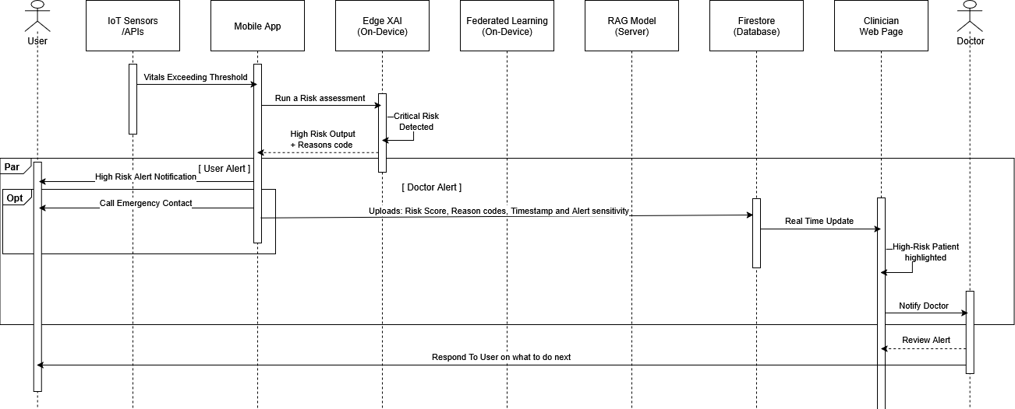

This diagram shows what happens when the system detects a potentially dangerous change in the user’s vitals. After receiving abnormal sensor readings, the app triggers the Edge XAI model to reassess the risk. If the output crosses a high-risk threshold, a critical alert is generated. The alert including risk score, reason codes, and timestamp is uploaded to the secure cloud database (PGSQL). From there, the clinician dashboard receives a real-time update, highlighting the patient as high priority. This diagram demonstrates the system’s collaborative monitoring loop and its ability to assist healthcare professionals proactively.

# System Architecture

## Architectural Design

The system is decomposed into ten subsystems:

* 1. **IoT & Wearable Sensor Layer -** All physiological data sources (consumer-grade and medical-grade)
  2. **Data Processing Layer –** Preprocessing and feature extraction
  3. **Edge XAI & Digital Twin –** On-device models + personalized health modelling
  4. **RAG Server –** Clinical knowledge retrieval + monitoring summary generator
  5. **Federated Learning Aggregation Service –** Local training + privacy-preserving global model updates
  6. **Patient Mobile Application –** Patient dashboard, trends, consultation
  7. **Doctor Clinician Dashboard –** Oversight, monitor patient summaries and trends
  8. **Cloud Backend –** FL aggregation, APIs
  9. **On-device Database –** Long term reading storage
  10. **Cloud Database -** User details, trends etc.
  11. **Authentication Service –** User login and signup

These subsystems communicate through REST endpoints. The frontend invokes API calls, the backend services coordinate business rules, the cloud database stores normalized tables.

## Decomposition Description

Subsystems breakdown:

* **IoT & Wearable Sensor Layer**
  + Collects raw physiological data from fitness wearables from APIs, medical devices through usage of custom IoT.
  + Streams real-time signals into the processing pipeline.
* **Data Processing Layer**
  + Cleans, aligns and filters incoming sensor data.
  + Extracts core features needed for modelling and inference.
* **Edge XAI & Digital Twin**
  + Runs on-device prediction models and generates explainability signals.
  + Maintains a continuously updated personalized physiological baseline (digital twin).
* **RAG Server**
  + Retrieves clinically validated knowledge and synthesizes context-aware summaries.
  + Bridges raw sensor insights with textual medical guidance.
* **Federated Learning System**
  + Executes local on-device model training to preserve data privacy.
  + Aggregates encrypted weight updates to refine the global model.
* **Patient Mobile Application**
  + Delivers real-time vitals, trends and personalized insights to the user.
  + Acts as the control plane for sensor integration and Edge XAI outputs.
* **Doctor Clinician Dashboard**
  + Provides clinicians with patient summaries, deviations and long-term trends.
  + Enables oversight without exposing raw personal data.
* **Cloud Backend**
  + Handles FL aggregation, API routing and coordination of backend services.
* **On-device Database**
  + Stores long-term readings, baselines and model states locally.
  + Supports offline functionality and privacy-first data retention.
* **Cloud Database**
  + Holds user profiles, trend aggregates for each user and non-sensitive metadata.
* **Authentication Service (Firebase Auth)**
  + Provides basic identity creation and verification for login and signup.
  + Issues and validates auth tokens; all user attributes are offloaded to the core database and mapped via UUID.

## Design Rationale

S.H.I.E.L.D has been structured as a set of modular services so each part of the system stays focused on a single responsibility and is easier to maintain. REST was chosen for the API layer because it’s simple, predictable, and works cleanly across mobile and IoT endpoints.

Both the on-device and cloud databases use relational models since our data is mostly structured and tied to clear relationships, making consistency and querying straightforward.

Authentication is delegated to Firebase Auth to avoid owning the security burden of credential management. We only store user details in our cloud database, linked through the user’s Firebase-issued UUID.

Federated Learning is built into the architecture to keep sensitive health data on the device. Each device trains locally and only sends model updates, not raw sensor data. This allows us to improve the global model without compromising user privacy.

## High Level System Architecture Diagram

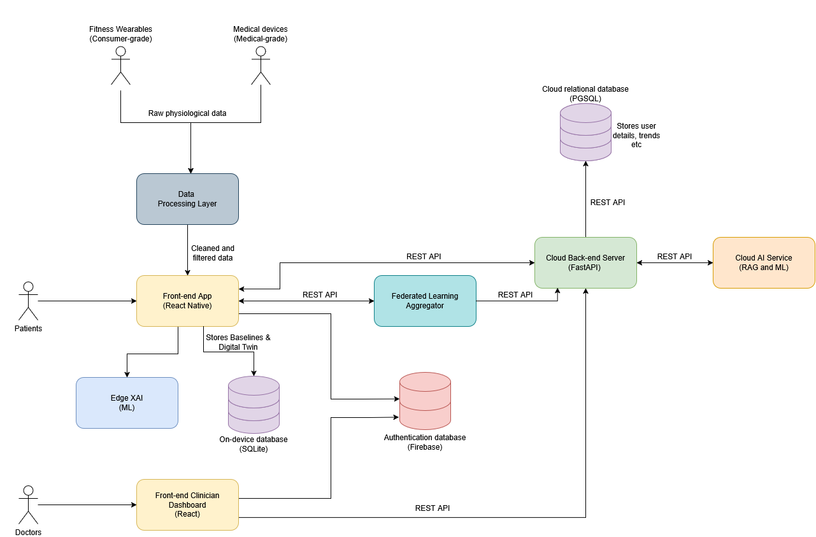

# Human Interface Design

## Mobile Application UI

#### A close-up of a list AI-generated content may be incorrect.A black and white image of a graph AI-generated content may be incorrect.Onboarding Pages

#### Login/Sign Up Pages

#### Disclaimer Page

#### Home Page

#### Vitals, Trends, Device Connection & My Health Page

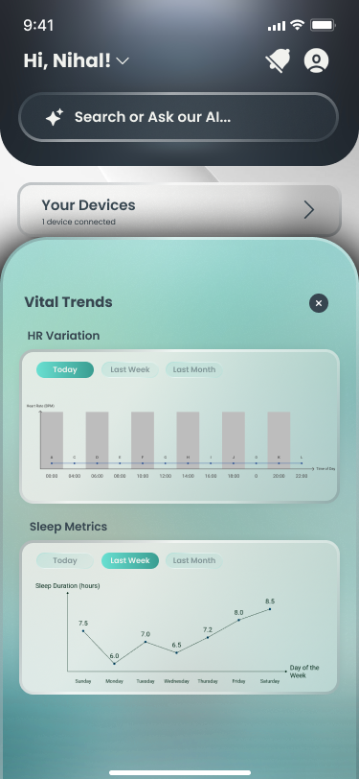

#### A screenshot of a chat AI-generated content may be incorrect.A screenshot of a medical application AI-generated content may be incorrect.Doctor Consultation and Communication Pages

#### Reports Storage & AI Summary Page

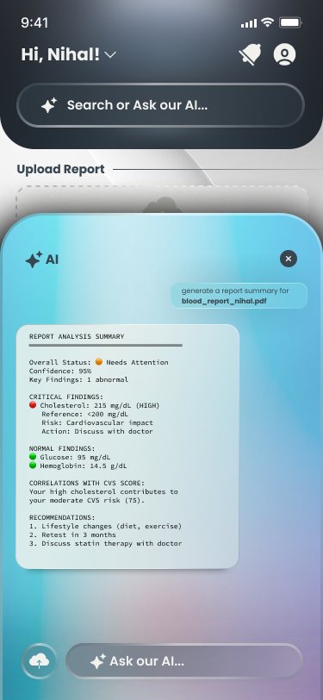

#### Profile Page

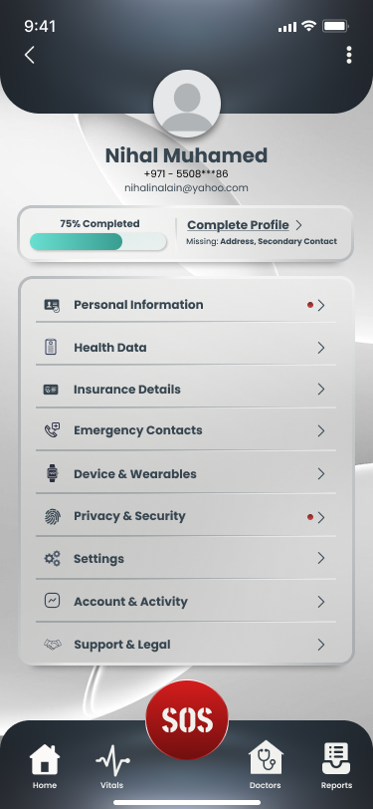

#### A screenshot of a phone AI-generated content may be incorrect.A screenshot of a phone AI-generated content may be incorrect.Emergency SOS Pages

## Web Portal UI

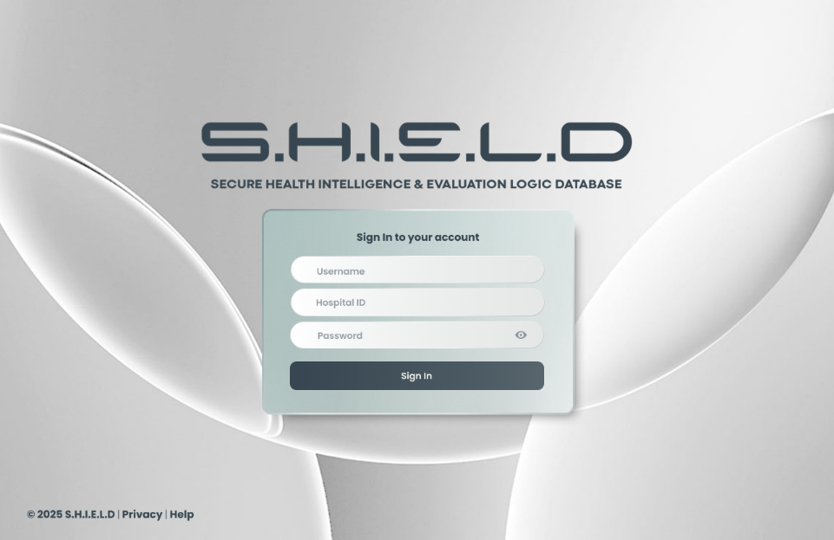

# Additional details for clarity of project

## Ethical Considerations

* **User Data Ownership & Informed Consent:**  S.H.I.E.L.D. ensures that users retain full ownership of their health data, with explicit consent required for all data processing and clinician access. The system clearly communicates that it is not a diagnostic tool and does not replace medical judgement.
* **Verified Medical Professionals & Doctor Credibility:** S.H.I.E.L.D. enforces strict role-based access control where only licensed doctors, nurses, and cardiologists can access patient insights. Clinicians are registered through their affiliated hospitals, which automatically validates their identity, qualifications, and regulatory compliance. This prevents impersonation, reduces risk of malpractice, and strengthens ethical transparency between patient and doctor.
* **Hospital-Integrated Background Verification:** Instead of allowing open sign-ups, S.H.I.E.L.D. partners with hospital systems for clinician onboarding, ensuring automatic background checks, license verification, and employment validation. This integration maintains a high ethical standard by guaranteeing that only legitimate medical professionals handle sensitive health insights, strengthening both privacy and security governance.
* **Privacy-Preserving AI Through Federated Learning:**  To ethically handle sensitive medical information, all raw data remains on the user’s device. Only anonymized model updates and processed risk insights are shared, preventing exposure of personal health details and reducing centralization risks.
* **Monetary Transparency & Fair Benefit Distribution:** Any monetization. including premium features, extended clinician dashboards, or institutional licensing will follow a transparent, user-first model. The app avoids selling user data or using health information for targeted advertising, maintaining strict ethical boundaries. Hospitals may benefit from improved triage efficiency, while users benefit from affordable early-risk monitoring, ensuring fair and ethical value exchange across all stakeholders.

## Privacy & Security

* **Strong Security & Access Controls:** All communication between devices, servers, and clinician dashboards is encrypted end-to-end. Additionally, doctors must be verified through hospital-based registration, ensuring that only qualified and authenticated professionals can access patient insights.
* **Bias Mitigation & Explainable AI:**  The system employs transparent Explainable AI (“Reason Codes”) to prevent black-box decision-making and reduce potential algorithmic bias. Ethical use of AI is ensured by testing across diverse data patterns to avoid unfair or misleading risk predictions.
* **Privacy-Preserving AI Through Federated Learning:** To ethically handle sensitive medical information, all raw data remains on the user’s device. Only anonymized model updates and processed risk insights are shared, preventing exposure of personal health details and reducing centralization risks.
* **Avoidance of Harm & Responsible Alert Design:**  Alerts are designed to encourage informed action without causing panic, anxiety, or false reassurance. The system follows a duty-of-care approach, ensuring predictions are communicated responsibly while emphasizing that serious symptoms require professional medical evaluation

# Conclusion

In conclusion, this design document presents a comprehensive framework for the Patient Health Monitoring System and Doctor Clinical Portal, covering system architecture, user interfaces, and workflows. By integrating real-time health monitoring, predictive analytics, and personalized insights, the project delivers a scalable and user-centred solution for remote patient care. The design carefully considers usability, ethical concerns, and privacy, providing a clear roadmap for implementation and future improvements.

# Work Distribution

|  |  |  |
| --- | --- | --- |
| **Member** | **Student ID** | **Work Assigned** |
| Avni Pramod | 8047984 | System Overview - Use Case Diagram + Additional details for clarity of project |
| Nihal Muhamed | 8276985 | System Overview - Activity Diagram |
| Mohammad Mawiz Ansari | 8335084 | System Architecture |
| Mohammed Shehin Kalady | 8526035 | System Overview - Activity Diagram |
| Sivajith Ajith Kumar | 8404744 | Human Interface Design + Additional details for clarity of project |
| Syed Sheharyar Ahmed | 8337354 | System Overview - Sequence Diagram |